Project overview:
The feature of interest is adding recipe section to Talabat mart App for meal prep inspiration and provide the ingredients based on the stock we have. So whenever the stock of a specific product is not available the recipe must be unavailable.
The main focus is , helping people to get inspired especially if they are beginners with cooking, and even if you are a cooking pro it will inspire you whenever you are stuck and cant decide what to cook.

Competitor overview

Kroger: considered as global competitor as I can’t find a local competitor, so I chose KROGER as it has the same idea behind the feature I want to add and treated it as my direct competitor.
A grocery store located in USA, it went digital and In 2014, they merged with Vitacost.com, one of the largest pure e-commerce companies and launched their APP several years ago to provide customers with convenient access to their services, including digital coupons, shopping lists, recipes, and online ordering for grocery pickup and delivery.

Breadfast: considered as an indirect competitor as it serves the same audience as talabat mart with slight differences.

Feature table
Feature | Talabat mart | Kroger | Breadfast
Product core | Instant grocery delivery | Comprehensive grocery shopping experience, with offline existence “stores” | Fresh and instant grocery and bakery delivery
Size of user base | Millions of users | Millions of users | 200000
Recipe display | Curated list | Curated list | No
Save recipe | yes | Yes | No
Add ingredients to shopping list | Yes | Yes
Offline access | No | Yes | No
rewards program | Yes | Yes | Yes
Personalized recipes | No | Yes | No

Mention the ways or sources you used to conduct the market analysis whether reports, search, online platforms, surveys or anything else:
Basic search, ChatGPT and a very insightful website called (similarweb).

Brainstorm exploratory interview questions that you will use in the user interviews:
-what is the most useful thing you find when using talabat mart?
- rate your experience while ordering your order from talabat mart?
- how did you find the overall user experience?
-talk about your cooking experience, at which level you consider yourself?
- do you stuck when thinking about what you are going to cook?
-are you planning your recipe first then you do your shopping based on this recipe?
-what if you are not aware of all the recipe ingredients?

Regarding this step I did not mange to conduct interviews so I used these questions in a form and sent it to whom I would conduct the interview with, and it went as following:
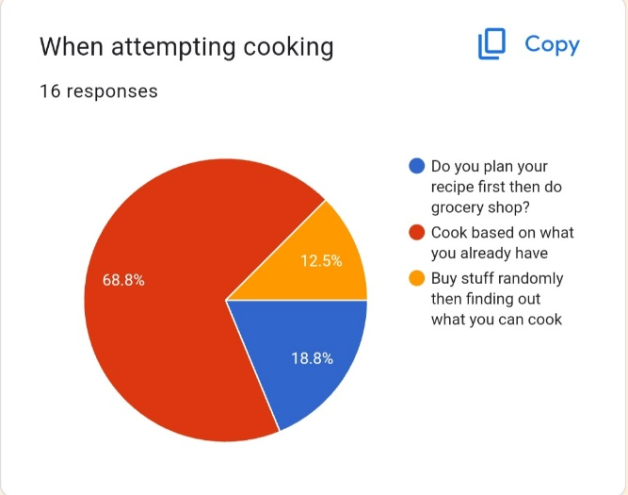
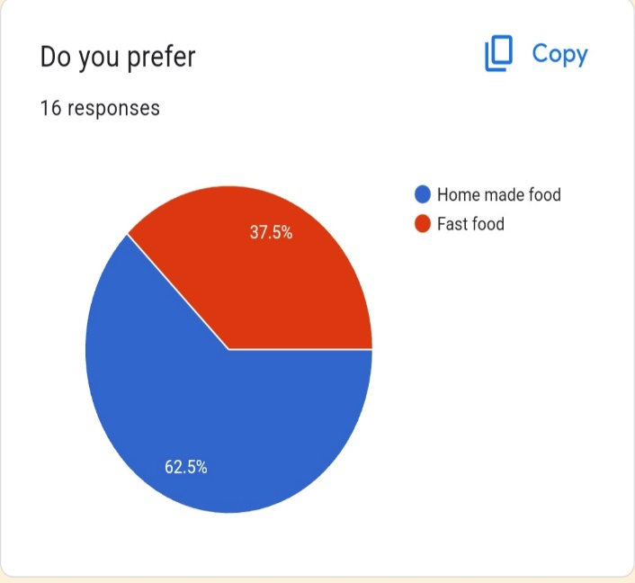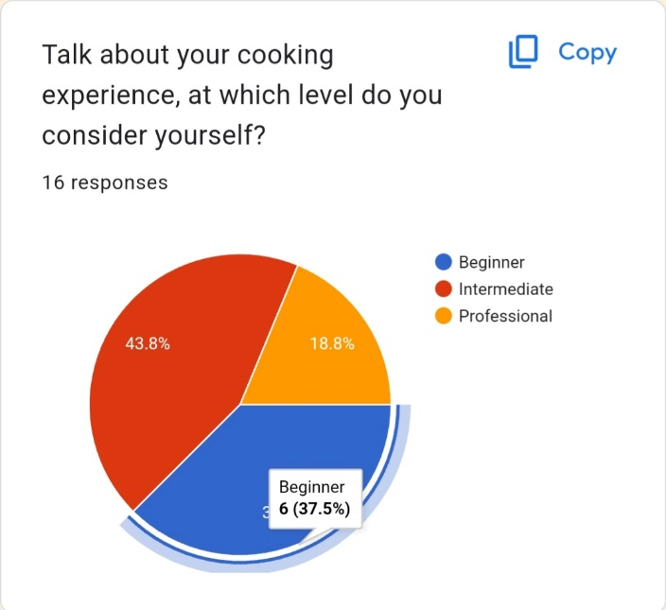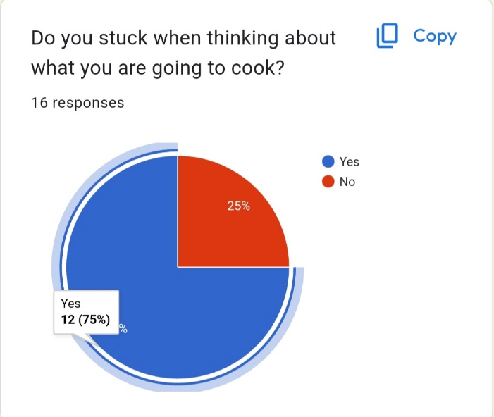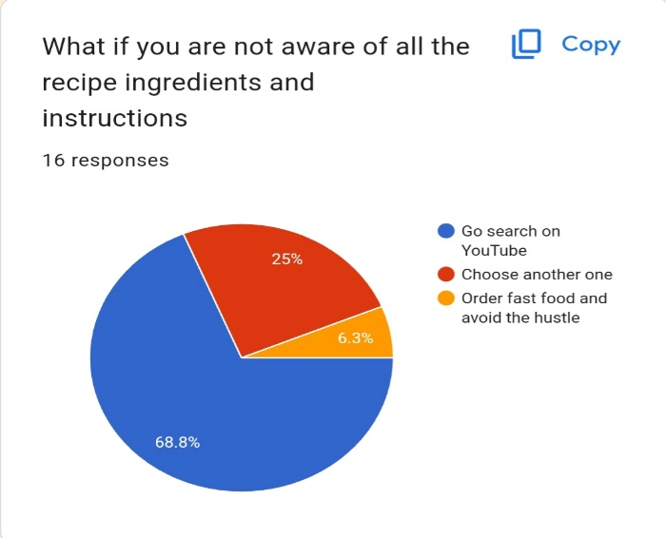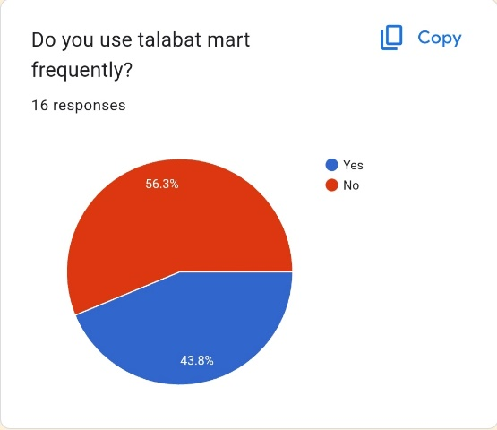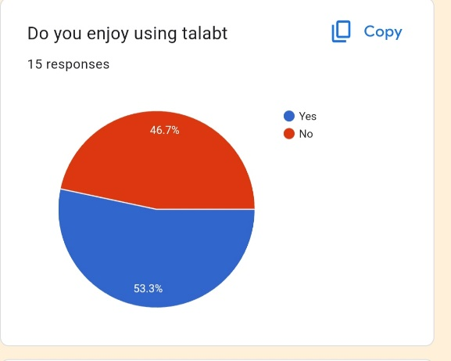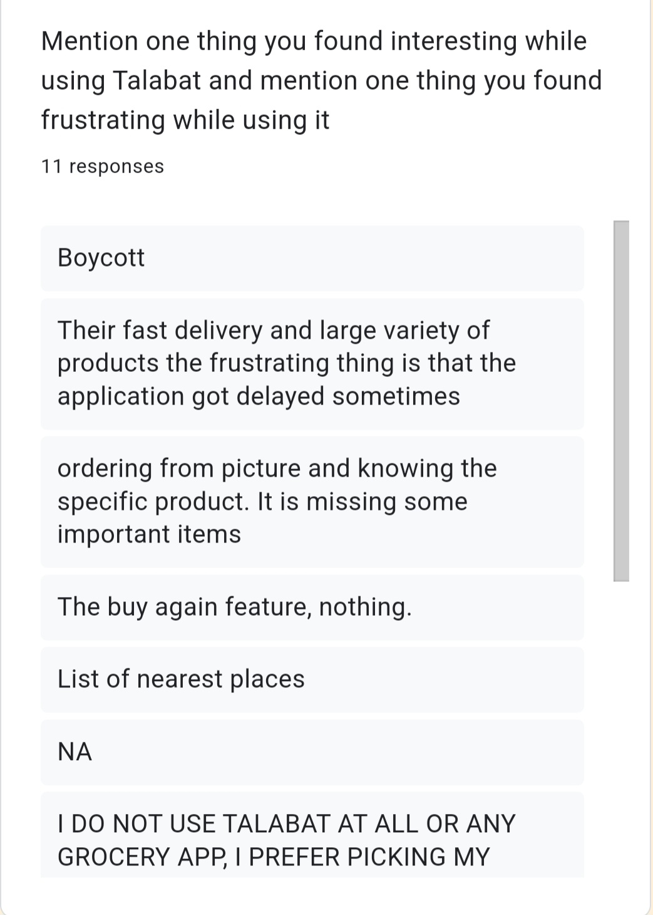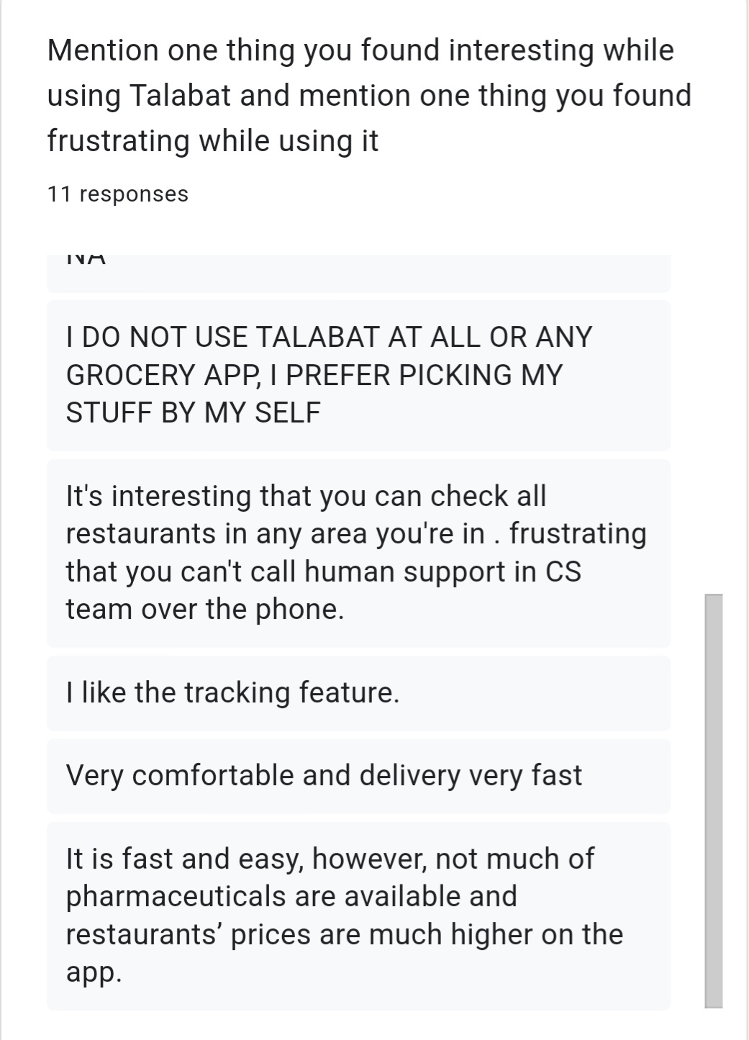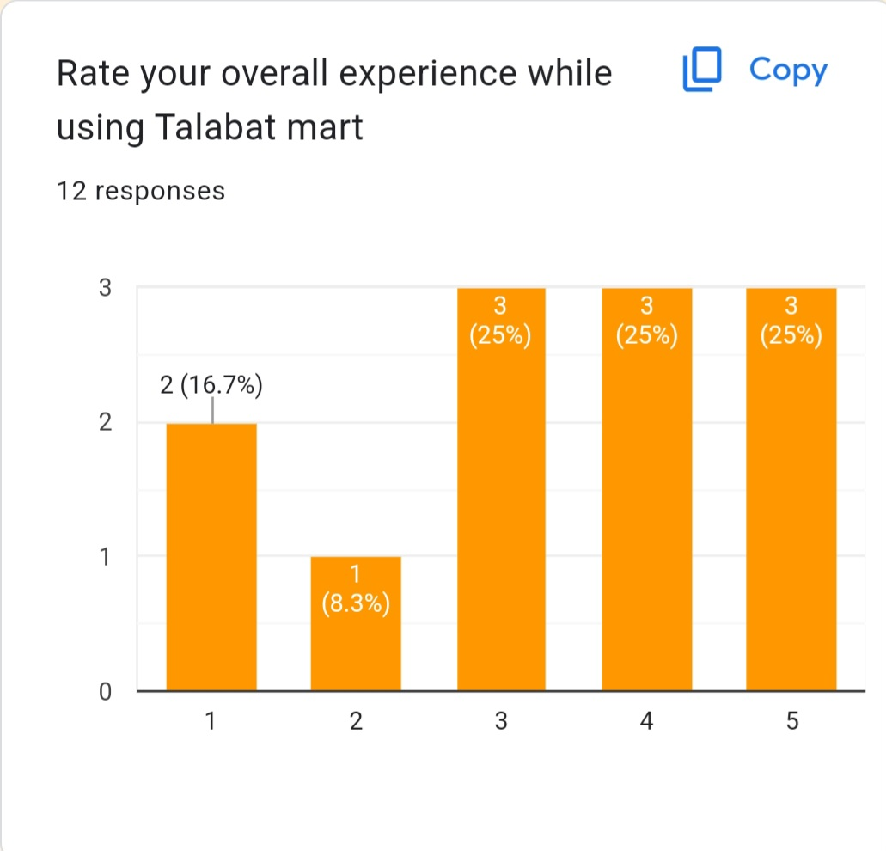

The feedbacks are very useful, overall we can use them not only for the sake of the feature we want to add but also for the enhancement of the overall user experience.

Explain How to reach potential users:
User personas, based on some research I crafted a user persona based on their needs and demands this feature will affect their lives directly in a positive proportional.
Partnerships and collaborations, we can collaborate with food bloggers, representing the new feature by trying the recipes we added, also we can collaborate with main food factories to mention our new feature and collab in their marketing campaigns.

Craft a user persona for your product/feature users:
Demographics:
1)
Name: Nermeen
Age: 29
Occupation: dentist
Location: Cairo , Egypt
Behaviors: hard working mom, works all day, studying at night , love online shopping, prefer healthy food for herself and her family (husband and little girl)
Goals: cook quick healthy delicious meals, maintain a diet for her family

Pain points:
not having enough time
not having meal inspiration
not knowing what to ingredients to buy
always a missing ingredient whenever attempting grocery shopping.

2)
Name: Mohamed
Age: 35
Occupation: Full time engineer
Behavior:
prefer homemade food over fast food, prefer to be in shape as he is a gym goer.
Pain points
Living alone
Not having any cooking or recipes reference
Not having enough time to choose what to eat.

MVP:
Describe the 1st MVP of your product/feature:
In order for my idea to be successful, the following must be true:
- Core features for THE MVP:
- Integrating with recipes provider platform, we can integrate with any kind of platform or even a TV channel and then we can use their databases to build our feature based on it.
- Provide detailed recipe information including ingredients, instructions and photos.
- All the ingredients should be available.
- Assumptions:
- Users will use the recipe inspiration feature to plan their meals.
- Users will prefer a curated list pf recipes over a vast database.
- Users will find it convenient to add the ingredients from recipes to their cart.
- Users will engage with the feature frequently and find it valuable.
- Integrating this feature will increase user retention and app usage.

- Identify your riskiest assumption:
- The riskiest assumption is, if user does not engage with the feature as expected it will indicate lack of interest leading to low adoption and retention rates.

- Create a hypothesis for your riskiest assumption:
- The hypothesis of the riskiest assumption is “if we add the recipe inspiration feature within our app more people will engage with the app, use it while prepping their meals make their lives much easier, this will lead to more app usage and customer retention”.
- State your Minimum Success Criteria:
- To consider this feature a success and worth building we have to achieve user engagement rate of at least 20% of our total active users base within the first month of launch, also we have to measure the session duration to see how user engage with the feature, because we may have engagement but not in an effective way so we can say that session could be 3 mins long per user, also we have to measure the percentage of app usage before and after launching the feature, we can assume that the app usage and retention should increase by 15%.

- Ideate more than one MVP:
The idea behind ideating more than one MVP is to understand the user more and more and their needs, also it helps us to be more flexible with market changes and user feedback, so here are some other MVP ideas we can consider in the context of our feature:
- Basic recipe display MVP: this include building very basic interface where users can find some recipes and ingredients but they can’t explore more, the goal is to get initial insight whether users are engaging with the feature and wants to explore more or not.

- Search and save MVP: this one includes the ability to search for recipes by specific key words, and can save the recipes to view them later, the goal is To asses if users are searching for specific recipes and find value in saving them for future

- Personalized recommendations MVP: this one for creating personalized recipes recommendations to users based on their purchase history, preferences and interactions, users can get their tailored recommendations in a form of notification.
This to measure if personalized recommendations drive higher engagement than statice curated ones.

